Controlling wireworms in potato production
Austrian Operational Group looking for alternative environmentally friendly control methods
Wireworms, the larvae of click beetles, cause major losses in potato production across Europe. The situation in recent years seems to be worsening due to climate change as Johannes Mayer, an Austrian potato farmer explains: “Wireworm damage is more significant in drier soils as the wireworms search for moisture, as well as food.” An Operational Group in Austria has been carrying out trials to find alternative control measures without using synthetic pesticides.
Wireworms spend up to 5 years in the soil, feeding on plant roots as well as tubers for several periods during the year. In Austria, wireworms cause about 10% loss of table potatoes, meaning 30,000 tons, amounting to several million euros. Eduard Paminger, another Austrian potato farmer interviewed during the project: “50% of my last harvest were damaged by wireworms, and this is actually equal to a total loss because it’s almost impossible to sort out the un-damaged potatoes.”
Explanations for the rise in wireworm damage can be linked to warmer global temperatures and drought. The reduction in numbers of farm bird populations also means they have fewer predators than before. Claudia Meixner from the project adds “Furthermore, we have found that unfortunately, reduced tillage and the practice of growing cover crops, in addition to having many advantages, also mean that the soil is undisturbed and this favours the development of eggs and young larvae.”
An independent environmental NGO from Austria set up an Operational Group ‘ARGE Drahtwurm’ in 2016 gathering farmers, researchers and environmental specialists together to work on the possibility of new control options under Austrian conditions of production. Claudia Meixner explains “We aimed to look into measures which would be compatible with organic and conventional production and would be both more environmentally friendly, efficient and sustainable.”
Field trials were carried out on 7 farms, applying a set of measures including insect pathogenic fungus (Metarhizium brunneum), analysis of area-specific application of this fungus which infects and kills the wireworms. Testing of carrier substrates and application techniques in different climatic conditions, as well as trap cropping, growing plants which are particularly attractive to the pest in order to draw them away from the main crop. Combinations of trap cropping were applied in the year prior to potato cultivation and insect pathogenic fungus or rotary cultivator treatments.
At the same time, project researchers carried out surveys on wireworms across the main potato production regions in Austria. They also analysed the biology of the wireworm, such as fluctuations in their activity during the year, the correlation between soil temperature, moisture and the presence of the wireworms in the top layer of the soil.
“We found that a reduction in the wireworm population can be achieved through the use of site-specific, multi-annual strategies using a combination of these measures,” says Claudia Meixner, “For example, through the use of attractive plants, wireworms gather in a specific area of the field and they can be dealt with in a targeted manner. Soil-damaging effects of tillage can therefore be limited and the amount of fungus applied reduced.”
The project has contributed to the development of forecast models to support the decision-making for the application of the different measures to control wireworm damage. These models have been widely shared amongst farmers and farm advisors in Austria.
Wireworms also affect other crops including maize, asparagus, carrots, turnips. The results of this project can therefore also be considered in other production contexts. Claudia concludes “This Operational Group has provided farmers in Austria with support in tackling a major issue in potato production, which contributes to the EU’s ‘Farm to Fork’ strategy to reduce the use of pesticides by 50% by 2030. We will continue to look deeper into this issue and optimise further the recommended measures.”

Background information

Project information
Contact:
Claudia Meixner - +431 812 57 30 - claudia.meixner@global2000.at

More information:

- Information on EIP-AGRI database
- https://www.zukunftsraumland.at/index.php?inc=project&id=1478
- https://www.global2000.at/arge-drahtwurm
- Video: https://www.youtube.com/watch?v=iOX2x0rpyNs
- Presentations: Präsentation GLOBAL 2000, Präsentationen MELES, Präsentation Bio Foschung Austria

EIP-AGRI contact
Ina Van Hoye
Communication manager Support Facility ‘Innovation & Knowledge exchange | EIP-AGRI’
ina.vanhoye@eip-agri.eu

+32 486 90 77 43

Project photos
Click on the pictures to download the high resolution versions. The pictures are free for use, please mention the copyright.

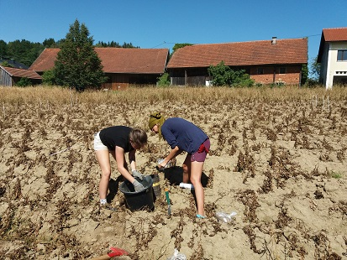 | 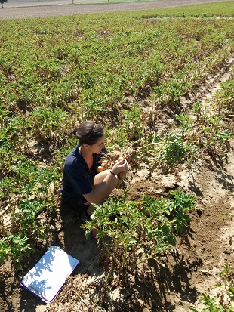
An Operational Group in Austria has been carrying out trials to find alternative control measures without
using synthetic pesticides.© ARGE Drahtwurm

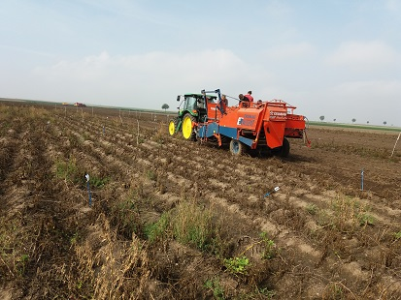 | 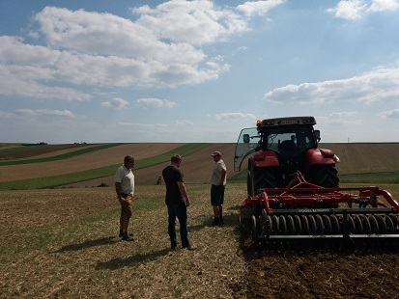
Field trials were carried out on 7 farms, applying a set of measures including insect pathogenic fungus (Metarhizium brunneum) and trap cropping © ARGE Drahtwurm

More information on sustainable use of pesticides

EIP-AGRI activities on sustainable use of pesticides

EIP-AGRI Focus Groups
- Integrated Pest Management (IPM) - Focus on Brassica species
- Non-chemical weed management in arable cropping systems
- Bee health and sustainable bee keeping
- Diseases and pests in viticulture
- Optimising profitability of crop production through Ecological Focus Areas
- Organic farming – Optimising arable yields
- Pests and diseases of the olive tree
- Protecting agricultural soils from contamination
- IPM practices for soil-borne diseases suppression in vegetables and arable crops
- Sustainable ways to reduce the use of pesticides in pome and stone fruit production

EIP-AGRI events
- EIP-AGRI Workshop Cropping for the future: networking for crop rotation and crop diversification
- EIP-AGRI workshop 'Organic is Operational'
- EIP-AGRI Workshop Conversion to organic farming
- EIP-AGRI Workshop Tools for environmental farm performance
- EIP-AGRI seminar: Healthy soils for Europe: sustainable management through knowledge and practice
- EIP-AGRI workshop: Shaping the EU mission ‘Caring for soil is caring for life’
- Agri-Innovation summit 2019 on the transition to agroecology
- EIP-AGRI brokerage event 'Get involved in the EU Mission: A Soil Deal for Europe'

EIP-AGRI publications
- EIP-AGRI Factsheet on IPM for Brassica
- EIP-AGRI Factsheet Soil-borne Diseases
- EIP-AGRI Factsheet on Diseases and pests in viticulture
- EIP-AGRI Brochure Organic is operational
- EIP-AGRI Brochure Sustainable and resilient farming: Inspiration from agro-ecology
- EIP-AGRI Factsheet on Ecological Focus Areas
- Agrinnovation magazine - Issue n° 7 - September 2020 (focus on soil health)
- EIP-AGRI Brochure Organic farming: Innovative approaches to support conversion

EIP-AGRI Videos
- AGRI Challenge: Non-chemical weed management in arable cropping systems
- AGRI Challenge: increasing biodiversity in agricultural landscapes
- AGRI Challenge: Pests and diseases in olive trees in Mediterranean regions
- AGRI Challenge: Monitoring bee health through beehive sensors

Inspirational ideas from the network
- Inspirational ideas: Vineyard app for plant protection (ES)
- Inspirational ideas: Crop health and pesticide resistance (UK)
- Inspirational ideas: Fighting grapevine trunk diseases (ES)
- Inspirational ideas: Dealing with pests from the air (FR)
- Inspirational ideas: Smart sensors to better understand plant growth (NL, Serbia)
- Inspirational ideas: Ideas for IPM (NL, SI, CH)
- Inspirational ideas: Changing weather conditions force olive farmers to start with pest management (IT)
- Inspirational ideas: Olive groves and drones - science fiction turned reality (ES)
- Inspirational ideas: Combatting weeds with non-chemical alternatives (PT)
- Inspirational ideas: A mobile app to monitor pests and diseases in Umbria, Italy (IT)
- Inspirational ideas: Biostimulants for sustainable agriculture (IT)
- Inspirational ideas: Chickens tackle weeds in Portuguese vineyards (PT)
- Inspirational ideas: Weed control without chemicals (IE)
- Inspirational ideas: Co-designing measures for grass weed control in arable systems (DE)
- Inspirational ideas: Weed control in organic viticulture (FR)
- Inspirational ideas: Sustainable farming in French Guiana (FR)
- Inspirational idea: Certification of Pesticide residue free fruit & veg (FR)
- Inspirational idea: Controlling wireworms in potato production (AT)

The EIP-AGRI network supports sustainable use of pesticides by promoting and sharing innovative practices. Read the EIP-AGRI Newsletter from September 2022 which was dedicated to sustainable use of pesticides. For all relevant EIP-AGRI network activities see the sustainable use of pesticides ‘spotlight page’.

Horizon 2020 multi-actor projects working on sustainable use of pesticides
- IPMWORKS - An EU-wide farm network demonstrating and promoting cost-effective IPM strategies: website - CORDIS
- IPMDecisions: Stepping-up IPM decision support for crop protection: CORDIS - website
- OPTIMA: Optimised Pest Integrated Management to precisely detect and control plant diseases in perennial crops and open-field vegetables: CORDIS - website
- INNOSETA Thematic network: Accelerating Innovative practices for Spraying Equipment, Training and Advising in European agriculture through the mobilization of Agricultural Knowledge and Innovation Systems: CORDIS - website
- WINETWORK Thematic network for the exchange and transfer of innovative knowledge between European wine-growing regions to increase the productivity and sustainability of the sector: CORDIS - website
- SMARTPROTECT Thematic network: SMART agriculture for innovative vegetable crop PROTECTion: harnessing advanced methodologies and technologies: CORDIS - website
- VIRTIGATION - Emerging viral diseases in tomatoes and cucurbits: implementation of mitigation strategies for durable disease management: website - CORDIS
- IPM Popillia - Integrated Pest Management of the invasive Japanese Beetle, Popillia japonica: website - CORDIS
- PESTNU - Field -testing and demonstration of digital and space based technologies with agro-ecological and organic practices in systemic innovation: website - CORDIS - video
- NOVATERRA - Integrated novel strategies for reducing the use and impact of pesticides, towards sustainable Mediterranean vineyards and olive grove: website - CORDIS
- WELASER - sustainable weed management in agriculture with laser-based autonomous tools: website - CORDIS
- BIOSCHAMP - Biostimulant alternative casing for a sustainable and profitable mushroom industry: website - CORDIS
- novIGRain - Sustainable storage of grains by implementing a novel protectant and a versatile application technology: website - CORDIS
- Excalibur - Exploiting the multifunctional potential of belowground biodiversity in horticultural farming: website - CORDIS
Further relevant multi-actor projects and thematic networks here.
Multi-actor projects are projects in which end users and multipliers of research results such as farmers and farmers’ groups, advisers, enterprises and others, are closely cooperating throughout the whole research project period.
Thematic networks are multi-actor projects which collect existing knowledge and best practices on a given theme to make it available in easily understandable formats for end-users such as farmers, foresters, advisers etc.

Operational Groups working on sustainable use of pesticides

424 Operational Groups working on sustainable use of pesticides are available in the EIP-AGRI Operational Groups database (update September 2022)

Austria: 10
Belgium: 9
Bulgaria: 1
Croatia: 2
Finland: 3
France: 41
Germany: 40
Hungary: 3
Ireland: 5
Italy: 92
Latvia: 5
Lithuania: 4
The Netherlands: 47
Poland: 2
Portugal: 34
Romania: 6
Slovenia: 11
Spain: 81
Sweden: 6
UK: 22

The CAP Agricultural Policy from 2023 to 2027
The reform of the Common Agricultural Policy (2023-2027) was formally approved end November 2021. Find all information on the new CAP on the European Commission website.

Innovation & knowledge exchange | EIP-AGRI
The European Innovation Partnership 'Agricultural Productivity and Sustainability' (EIP-AGRI) was launched in 2013 by the European Commission in a bid to promote rapid modernisation of the sectors concerned, by stepping up innovation efforts. The EIP-AGRI aims to foster innovation in the agricultural and forestry sectors and in rural areas by bringing research and practice closer together – in research and innovation projects as well as via the EIP-AGRI network. Also grassroots ideas from farmers get developed into innovations through the so-called Operational Group innovation projects. The EIP-AGRI aims to streamline, simplify and better coordinate existing instruments and initiatives, and complement them with actions where necessary. More information at the ‘About section’ of the EIP-AGRI website.

EIP-AGRI Operational Groups
- 98 Rural Development Programmes provide support to innovative EIP Operational Group projects*
- Over 3200 Operational Groups are planned to be established under the approved RDPs (2014 – 2020)
- More than 2400 Operational Groups projects have been selected for funding and are currently ongoing (or already finished)*. Member States will still start more Operational Group projects which may run until 2025 (under current transitional rules for EU rural development programmes). Find information on all of them in the EIP-AGRI database.

* Information officially submitted to the European Commission by RDP Managing Authorities (November 2020)

EIP-AGRI Operational Groups are groups of people who work together in an innovation project funded by Rural Development Programmes (RDPs). They bring together partners with complementary knowledge. The composition of the group will vary according to the theme and specific objectives of each project. Farmers, advisors, scientists, businesses or other relevant partners work together to find practical solutions for specific problems or opportunities for European farmers and foresters. Farmers and foresters need to cooperate throughout the project to ensure that the innovative solutions are practical and likely to be quickly applied in the field. Read the basic principles. Innovation support services (including advisors with a focus on innovation), and in particular innovation brokering, can therefore play a crucial role in getting worthwhile projects off the ground by facilitating contacts.

Check out the section on the EIP-AGRI website dedicated to 'Operational Groups', including:
- more than 2400 Operational Groups available in the database
- detailed information on how to set up Operational Groups, on supporting networks and relevant EIP-AGRI seminars and workshops
- links to results and contact details of ongoing Operational Groups in the EIP-AGRI database
- a list of all RDP Managing Authorities

EIP-AGRI videos
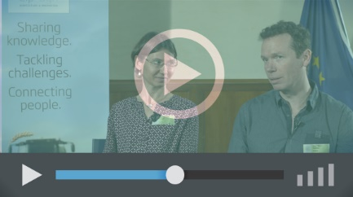 | 
Operational Groups – first experiences | Operational Groups – collaborate to innovate
 | 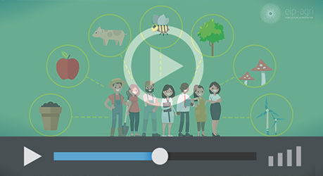
Innovation Support Services, supporting innovation in EU farming and forestry | EIP-AGRI Focus Groups, sharing knowledge to inspire innovation

AKIS: building effective knowledge flows across Europe

EIP-AGRI, 7 years of innovation

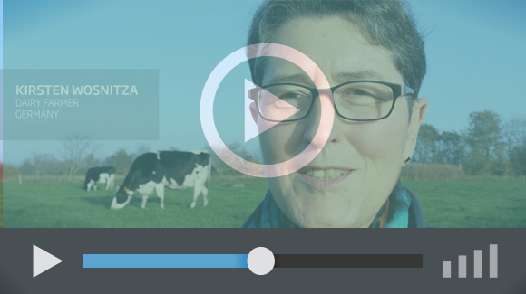 |  | The enthusiasm of the EIP-AGRI network members is essential to the success of the EIP-AGRI, and in ensuring that everyone can benefit. Watch this EIP-AGRI video to hear researchers, farmers, advisors, Managing Authorities and National Rural Networks explain how the EIP-AGRI has helped them over the past 7 years.
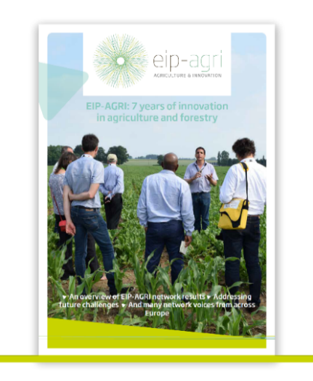 | Since 2013, the EIP-AGRI has been promoting interactive innovation to make EU agriculture and forestry more sustainable, productive, and fit for the future. This report shows how the EIP-AGRI network has grown into a thriving network. Read the report

