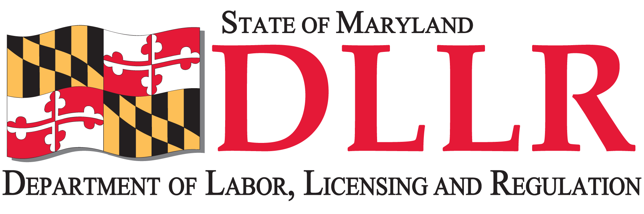

PREVAILING WAGE COMPLAINT FORM

I hereby make the following complaint under the "Prevailing Wage Law" of Maryland. State Finance & Procurement Article, Section 17-201 through Section 17-226 - Annotated Code of Maryland

Name: Social Security No.:

Address:

City: State: Zip:

Telephone:

Email Address:

Name of Employer or Company:

Employers Address:

Work Site Location:

Date Employment Began: Date Terminated:

A. Job Classification: Hourly Rate:

B. Other Classifications: Hourly Rate:

Hours worked in classification A: Hours worked in classification B:

Statement of claim:

I declare and affirm that the matters set forth herein are true and correct.

Date Signature

DON'T FORGET TO INCLUDE ALL DOCUMENTATION, INCLUDING YOUR PAY STUBS.

Department of Labor, Licensing and Regulation
Division of Labor and Industry
Prevailing Wage Unit
1100 North Eutaw Street, Room 606
Baltimore, MD 21201
Telephone Number: (410) 767-3068 • Fax Number: (410) 767-2986
E-mail: dldliprevailingwage-dllr@maryland.gov
Rev. 9/2015

