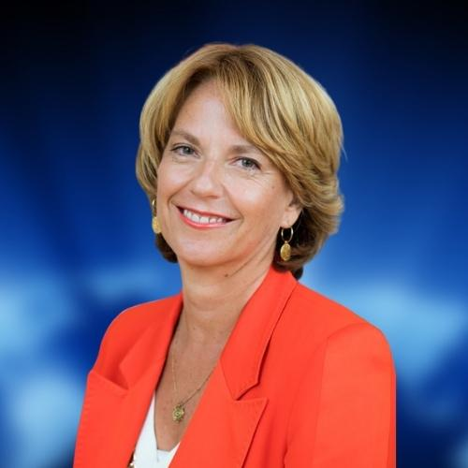 | Christina KOKKINAKIS
Nationality: | Austrian
Academic qualifications: | - International Relations (1995)  - Master of Arts degree in History and French literature (1993)
Professional experience: | - Since 1 January 2022 Deputy Managing Director Global and Director for Values and Multilateral relations at the EEAS  - 2019-2021 Permanent Representative of Austria to the Political and Security Committee (PSC) of the European Union  - 2017-2019 Director for the EU Common Foreign and Security Policy (CFSP) at the Austrian Federal Ministry for Europe, Integration and Foreign Affairs  - 2016-2017 Director for COREPER 1 at the Austrian Federal Ministry for Europe, Integration and Foreign Affairs  - 2012-2016 European External Action Service (EEAS), Head of Political Section – Human Rights at the European Union Delegation to the United Nations in Geneva  - 2009-2012 Head of Political Section and RELEX/RELEX SANCTIONS Counsellor at the Permanent Representation of Austria to the European Union  - 2005-2009 Deputy Permanent Representative of Austria to the United Nations in Geneva  - 2004 -2005 Senior Foreign Policy advisor on UN, OSCE, CoE, Human Rights, International Law to the Foreign Minister of Austria Ursula Plassnik  - 2003-2004 Senior Foreign Policy advisor on UN, OSCE, CoE Human Rights as well as on bilateral relations with special focus on Middle East and Latin America to the Foreign Minister of Austria Benita Ferrero-Waldner  - 2001-2003 Deputy Head of Mission of Austria to the Czech Republic  - 1998-2001 Foreign Policy advisor to the Vice-Foreign Minister of Austria Benita Ferrero-Waldner  - 1997-1998 Secretary of Legation in the Division for United Nations and multilateral relations  - 1996-1997 Attachée at the Austrian Cultural Institute in London  - 1995 – 1996 Attachée at Permanent Mission of Austria to the OSCE in Vienna and later to the United Nations in Vienna  - 4 September 1995 Joined Austrian Diplomatic Service
Language Skills: | - German  - English  - French  - Spanish  - Italian  - Greek  - Dutch  - Arabic (beginner)

